**BOARD OF REGENTS: 09/09/16**

**Agenda Item: 12.F.1.**



**Murray State Board of Regents Statement and Position on Performance Funding**

The Murray State University Board of Regents affirms that performance funding is a viable process as it relates to the accountability of our postsecondary institutions to our students and to the citizens of the Commonwealth.

The Murray State Board of Regents supports alignment of performance funding initiatives which emphatically recognize quality as it directly relates to the rigor, relevance and excellence that a Murray State University degree imparts.

As performance funding will communicate the values and desired outcomes of all public universities and community colleges of the Commonwealth, it is good public policy, if not a moral imperative, that University and Civic leaders place an emphasis on quality and effectiveness in determining the metrics for any performance funding model.

This commitment to quality higher education is in complete alignment with the Postsecondary Education Improvement Act of 1997, Kentucky's seminal act regarding higher education, which clearly articulates the goal to provide statewide access to postsecondary degrees of quality.

Therefore, Kentucky's performance funding model must include measures of quality and education effectiveness, in addition to basic quantity measures.

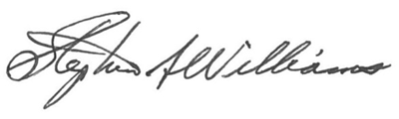

________________________________________

Stephen A. Williams

Chair – Board of Regents

09/09/2016

**COMMITTEE ACTION: Approved, Legislative and Economic Development**

**Committee.**

**BOARD ACTION: Approved.**