Starfish Student Success Network
Student Guide: Raise Your Hand

Welcome to the Starfish Student Success Network! Murray State cares about you and your success! That’s why we’re using the Starfish Student Success Network to empower you to be successful.

Need help in your class or with a personal issue? Just need help and not sure where to start?
Raise Your Hand with Starfish!

Log into Starfish through myGate Academics tab

Click on the “hamburger” button to open the menu.

Click the “Raise Your Hand” button on the left side of your Starfish menu
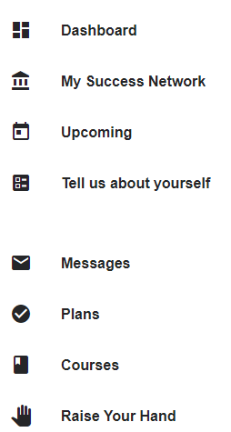
You can also click on this icon to go to the Raise Your Hand feature:

Complete and submit the form that opens and help is on the way!

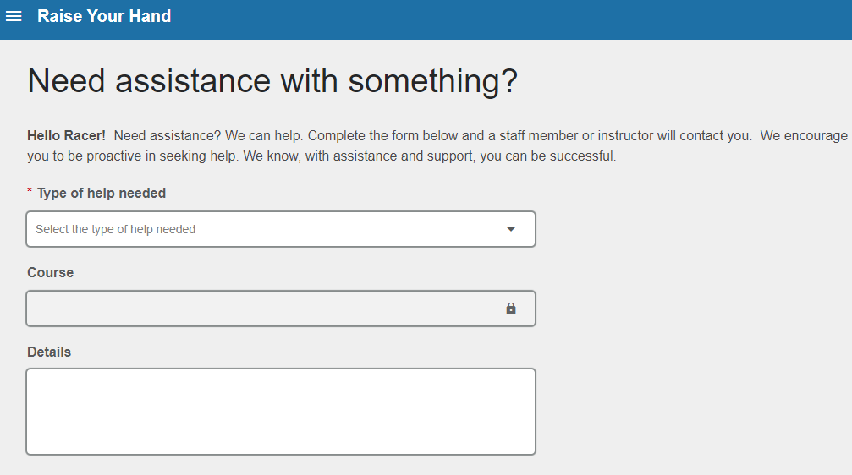

If you need assistance, please contact the staff in Student Engagement and Success at msu.success@murraystate.edu, or msu.starfish@murraystate.edu
We enjoy helping Racers succeed!

