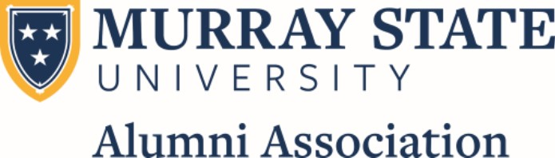

**Board of Governors Member Responsibilities**

Thank you for your interest in the Murray State University Alumni Association Board of Governors. Your time, talents and generosity are never more in demand than they are right now.

**Core Pillars of the MSUAA:**

* Alumni Engagement
* Student Recruitment
* Philanthropy
* Public Advocacy

**History:**

The Murray State Normal and Teachers College Alumni Association was organized June 1, 1926, during a meeting in Wells all immediately following the commencement of the first graduating class of 16 in the Little Chapel. Since that first graduation ceremony, over 75,000 students have earned degrees from Murray State. The MSUAA was established to provide an opportunity for graduates, former students, faculty, staff and other friends of Murray State to coordinate their efforts on behalf of the institution. The Alumni Association is a dues-based membership organization that supports integral programming designed to advance the mission of Murray State University and create meaningful connections among our global alumni population.

**Mission:**

The MSUAA connects, celebrates and engages alumni and friends of the University through communication, activities and events to foster lifelong relationships that support the mission and strategic plan of Murray State.

**Vision:**

The MSUAA will be recognized internationally for excellence in alumni engagement through communication, activities and events, and for collaborating with other University units to produce more effective student recruitment, donor solicitation and stewardship and legislative advocacy.

**Purpose:**

To coordinate the efforts of alumni on behalf of Murray State University, the MSUAA serves as a liaison between the University and its alumni constituency and enables graduates to maintain a close bond with their alma mater. The MSUAA promotes the general interests of Murray State by affording alumni opportunities to work together to engage fellow alumni and advance the mission of their alma mater.

**Academic Excellence:**

Each year the MSUAA awards the Distinguished Alumni award to alumni who have distinguished themselves above their peers personally and professionally and who have made an impact at the local, state and national level. The MSUAA also has the privilege of awarding annually the Distinguished Professor Award. Recipients of the honor are nominated by their students and selected by the Executive Committee of the MSUAA.

**What is Expected:**

While the Board is comprised of volunteers, each Board member is expected to and be willing to contribute their time, talents and generosity to Murray State through their commitment and work for advancing the cause of the MSUAA and the University.

As a member of the MSUAA Board of Governors you are expected to:

* Attend all Board meetings (2 per year – Distinguished Alumni weekend in April and Homecoming weekend in October) in-person, telephonically or virtually.
* Participate on committees and in other meetings throughout the year as deemed necessary by the Executive Council.
* Contribute your talents and skills to help Murray State achieve its goals and objectives and those of MSUAA.
* Apply the knowledge, skills and abilities you gained, learned, or perfected at Murray State for Murray State.
* Complete at least one of the following:
  + Donate $250 per year over your three-year term in order to become a Lifetime Member of the MSUAA by the term’s end, OR
  + Maintain yearly membership by paying annual dues ($40 Single Membership/$60 Joint), volunteer a minimum of five hours of services per year and recruit five new MSUAA members over the length of your term.
* Be good stewards of the office to which you are elected and good stewards of the University.