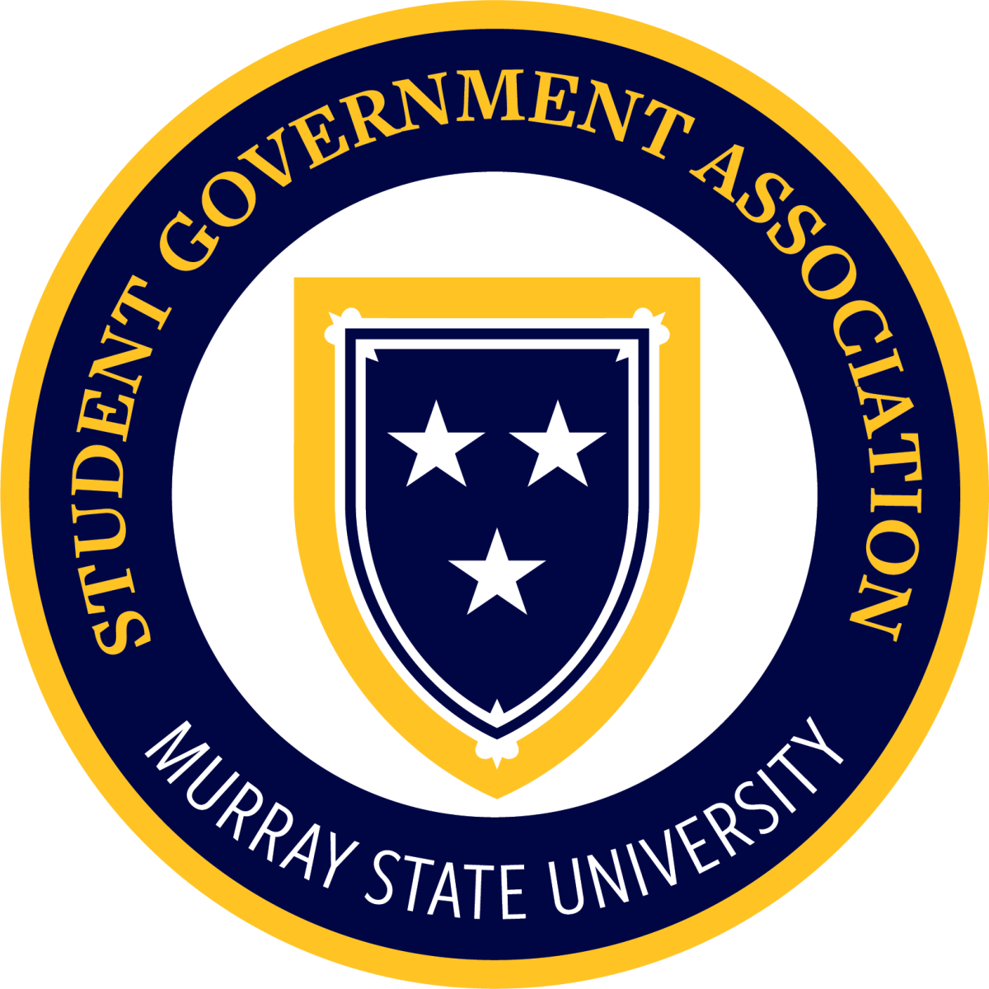

Murray State Student Government Association
MEETING MINUTES
Come to order: 4:30 pm
Approval of last meeting’s minutes motioned by Jesse Hutchens and seconded by Raeya Burton
Presenters/Guests:
Branch Reports:
Claire Wisnoski (Chief Justice):
- First Meeting last week
- Everyone on Judicial Board has been trained
- Next Meeting Sept 24th
- Working on DoorDash parking spots
- Hazard lights do not get you out of a parking ticket

Brenna Conners (Residential College President):
- Spirit Points Night at Tap
- Res Colleges will be decorating banners for Homecoming

Academic College Senator Reports:
Jesse Hutchens, Caroline Smith (College of Business):
- No report

Sydney Foltz, Libby McBryde, Sadie Youngblood (Education & Human Services):
- Homecoming Breakfast at Murray Middle on Oct 17 8-9:30. RSVP by Oct. 2nd
- HPE Horseplay Event
- Dr. Samir Patel as current interim dean

Brady Doninger, Emma Henderson (Humanities & Fine Arts):
- If you want live music at your events, reach out to Brady

Adyson Chambers, Omar Khatib, Oak Shain (Science, Engineering, & Technology):
- STEM/OSH Career Fair

Kennedy Likens, Ella Engleau, Julia Marshall (Hutson School of Agriculture):
- Fall on the Farm

Karah Southworth, Emma LeClere, Jocelyn Reddick (College of Nursing and Health Professions):
- White Coat Ceremony
- Mason Hall to be completed Oct

Gary Rogers (Senator at Large, Ducks Unlimited)
- Club raises money to preserve wetlands
- Look forward to raffles and auctions

John Phillip Foley (Senator at Large, MedLife)
- Meet weekly m at 5pm
- Guest speakers, volunteering, work with red cross and other orgs,
- Study abroad program for real-world experience
- If interested, contact Reid Martin, MedLife chapter president

Next Week’s Senators at Large: Issac Kinsey and Sophie Hollowell

Residential College Senator Reports:
Kirsten Laughary (Clark College):

Finn Stroud (Elizabeth College):

Chloe Kirchdorfer (Hart College):

Luke Tompkins (Hester College):

VACANT (Regents College)

Edie Rodgers (Richmond College):

Raeya Burton, Natalie Wielgos (Springer/Franklin College):

Allina Decker, Braden Lacefield (White College):

Director Reports:
Carson Todd (Elections, Membership, & Legislation):
- Freshman Senator Results during New Business
Ellington Varner (Enrollment Management & Student Success):
- No report

Baleigh Arnold (Public Relations):
- No report

Hannah Murphy (University Affairs):
- No report

Carson Weiss (Government Relations):
- Looking for guest speakers

Natalie Shemwell (Community Outreach):
- Donate items to Campus Thrift

Mary Brooke Stith (Chief of Staff):
- No report

Officer Reports
Will Van Horn (VP of Student Connections):
- Redoing tier system for student orgs.
  - Gold, Silver, Bronze
- Student Org of the year
- Student Org of the month
Cameron Wright (VP of Administration):

Henry Porter (Executive VP & President of Campus Activities Board):
- Calvert City Drive In
- Turtlebox giveaway upcoming
- Next Cab Meeting Sept 28th
Cesar Villeda (President & Student Regent):
- Strategic Planning Task Force, focus group meetings upcoming
- New graduation regalia
- Student worker minimum wage has increased
University Committee Reports
Dr. Ron K. Patterson (President’s Office):
- Student worker minimum wage has increased
Dr. Don Robertson (Student Affairs Office):
- Family Weekend was a success
- Phoenix Day
- Welcome back mixer International Student Organization
- 9,988 student enrolled

Chief Ryan Orr (University Police):
- No report
Kylie Merrick (Dining Services):
- Speakeasy event on the 24th
Mr. David Looney (Auxiliary Services):
- No report
Kade Gambill (Advisor to SGA & Student Organizations)
- Magician on campus the Sunday after Homecoming, tickets available
- Need ushers for this event
- Racer Leadership Institute
- Career Services Career Closet pop-ups
Announcements:
- None

Old Business:
- None
New Business:
- Resolution 91-26-R1
  - Appreciation of Jason Youngblood’s career at Murray State University
- Swearing in of vacancy positions
- Approval of slate of candidates for vacancy positions Maragret Wilson (Senator at Large), Miley Humphrey (Senator at Large), Parker Johnson (College of Humanities and Fine Arts Senator), Chris Cummins (College of Business Senator), Nic Fox (Regents College Senator), Laura Schreer (Elizabeth College Senator), Alex Kimbrough (Richmond College Senator)
  - Passes unanimously, new senators are confirmed
- Freshman Senate Election Results
  - 586 total votes cast
  - Sadie Grace Arterburn
  - Ethan Morgan
Motion to adjourn meeting made by Libby McBryde and seconded by Brady Doninger. Motion Passed. Adjourn at 5:08 pm.

