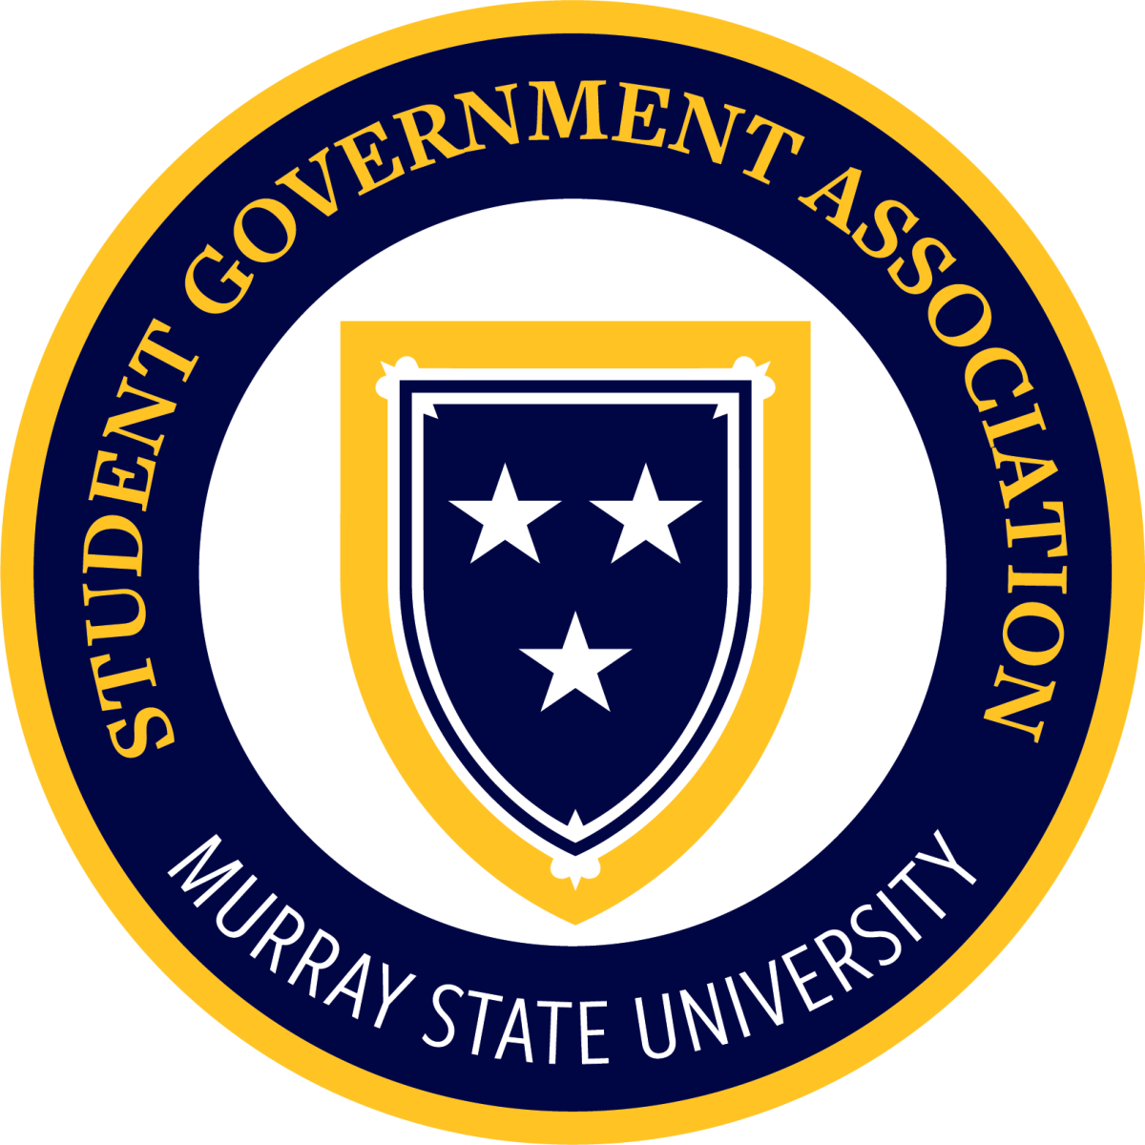

Murray State Student Government Association
MEETING MINUTES
Come to order: 4:30 pm
Approval of last meeting’s minutes motioned by Jesse Hutchens and seconded by Libby McBryde
Presenters/Guests:
Abigail Cox: Oakley Resource Center and Student Lounge
- Campus Thrift 9-4 in Oakley, donate items, open for all students
Branch Reports:
Claire Wisnoski (Chief Justice):
- Make sure to park correctly
- Information video coming soon

Brenna Conners (Residential College President):
- Leadership Conference Nov 6-8 at Chapel Hill, can take 15 students, everything but meals is covered

Academic College Senator Reports:
Jesse Hutchens, Caroline Smith (College of Business):

Sydney Foltz, Libby McBryde, Sadie Youngblood (Education & Human Services):

Brady Doninger, Emma Henderson (Humanities & Fine Arts):

Adyson Chambers, Omar Khatib, Oak Shain (Science, Engineering, & Technology):

Kennedy Likens, Ella Engleau, Julia Marshall (Hutson School of Agriculture):

Karah Southworth, Emma LeClere, Jocelyn Reddick (College of Nursing and Health Professions):

Residential College Senator Reports:
Kirsten Laughary (Clark College):
- Trail mix event today

Finn Stroud, Laura Scheer (Elizabeth College):

Chloe Kirchdorfer (Hart College):
- Journaling Sept 30
- Roblox night Oct 2
- Oktoberfest

Luke Tompkins (Hester College):
- Karaoke Friday at 5

Nic Fox (Regents College):

Edie Rodgers, Alex Kimbrough (Richmond College):
- No report

Raeya Burton, Natalie Wielgos (Springer/Franklin College):

Allina Decker, Braden Lacefield (White College):

Isaac Kinsey (Senator at Large, Psychology Club
- Meet Tuesdays at 5 in Wells Hall 111
- Open to any students
Sophie Hollowell (Senator at Large, Honors Student Council)
- 10 elected students from each class in the honors college
- Meet every Tuesday at 9PM in Franklin

Ethan Morgan, Sadie Grace Arterburn (Freshman Senators)

Director Reports:
Carson Todd (Elections, Membership, & Legislation):
- Making resolution templates so all students can make them
Ellington Varner (Enrollment Management & Student Success):
- First freshman council meeting next Tuesday at 4:30
- Recruit freshmen to join freshman council

Baleigh Arnold (Public Relations):
- Working on posts

Hannah Murphy (University Affairs):
- Sept 24, International Student Mixer
- Sept 26, Fall on the Farm
- First Play at 2:30 on the 26th, Johnson Theater
- All Major Career Fair Sept 29
- OSH/STEM Career Fair Sept 30

Carson Weiss (Government Relations):
- No report

Natalie Shemwell (Community Outreach):

Mary Brooke Stith (Chief of Staff):
- No report

Officer Reports
Will Van Horn (VP of Student Connections):
- Re-register your student orgs.
Cameron Wright (VP of Administration):

Henry Porter (Executive VP & President of Campus Activities Board):
- Next Cab meeting Sept 28
- Extending hours in library during finals week
- More library supplies for students
Cesar Villeda (President & Student Regent):
- Met with Dr. Twigg, change graduation regalia to be more Murray State themed, will be used for spring semester
- New regalia will cost about $22 more than original
- Canva for students, maybe starting in January

University Committee Reports
Dr. Ron K. Patterson (President’s Office):

Dr. Don Robertson (Student Affairs Office):
- Support our athletics teams

Chief Ryan Orr (University Police):
- No report
Kylie Merrick (Dining Services):
- Speakeasy event
Mr. David Looney (Auxiliary Services):
- No report
Kade Gambill (Advisor to SGA & Student Organizations)
- Pick up your homecoming sweatshirts
- Download RacersConnect app
Announcements:

Old Business:

New Business:

Motion to adjourn meeting made by Parker Johnson and seconded by Sydney Foltz. Motion Passed. Adjourn at 5:00 pm.

