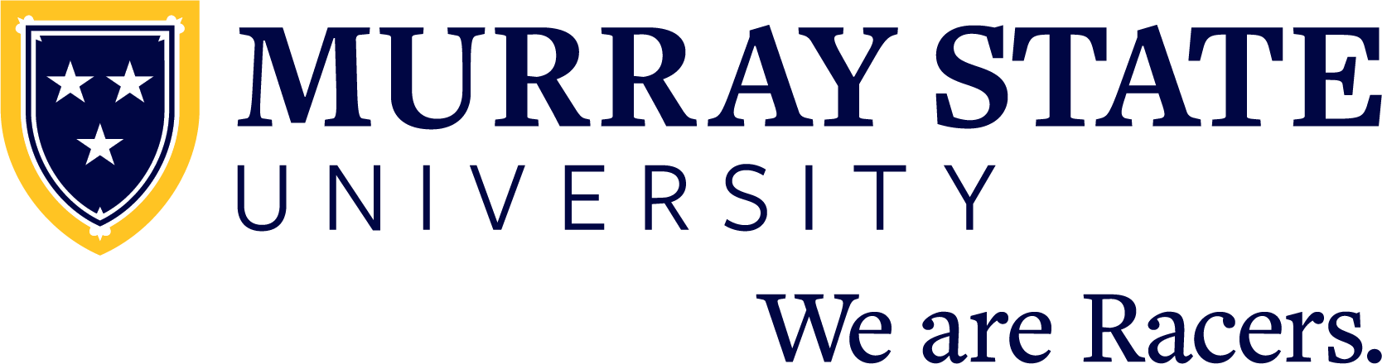

FOR IMMEDIATE RELEASE: Month Day, 20XX

(Student name) graduates from Murray State University

MURRAY, Ky. — (Student name) from (city, state and/or country) has graduated from Murray State University with a (Bachelor/Master/Doctorate/etc.) of (Arts/Science/etc) in (major).

(Student name) is the (child) of (parent/guardian name or names).

(INCLUDE ACADEMIC HONORS/AWARDS HERE)

Murray State University hosted commencement ceremonies for spring and summer 2025 graduates on Saturday, May 10 at the CFSB Center.

A total of 1,654 degree applicants from 38 states and 16 countries comprised the graduating class including doctoral, specialist, master’s, baccalaureate and associate degrees.

Recognized nationally as one of America’s best college values, Murray State is the #1 “Best Value School” in the South region by U.S. News and World Report as part of the publication’s annual rankings.

Murray State has been recognized nationally for both quality and value by the following publications:
- Washington Monthly - “Best Bang for the Buck”
- Wall Street Journal - “Best Colleges in the United States”
- Niche - “Best Colleges in Kentucky”
- Colleges of Distinction - a “2024-25 Best College”

Admission for the 2025-26 academic year at Murray State University is open as future Racers can apply today at admissions.murraystate.edu. Students interested in joining the Racer family can also learn more as well as schedule a campus visit by calling the office of recruitment at 270-809-2896 or emailing msu.recruitment@murraystate.edu.

Since 1922, Murray State University has provided a collaborative, opportunity-rich living and learning community that fosters personal growth and professional success through a high-quality college experience. Students receive support from inspiring faculty and staff and will join a distinctive campus community — the Racer Family. Murray State prepares the next generation of leaders to join more than 80,000 successful alumni who make a difference in their community, across the country and around the world. The University’s main campus is located in Murray, Kentucky, and includes five regional campuses in Ft. Campbell, Henderson, Hopkinsville, Madisonville and Paducah. Learn more at murraystate.edu.

