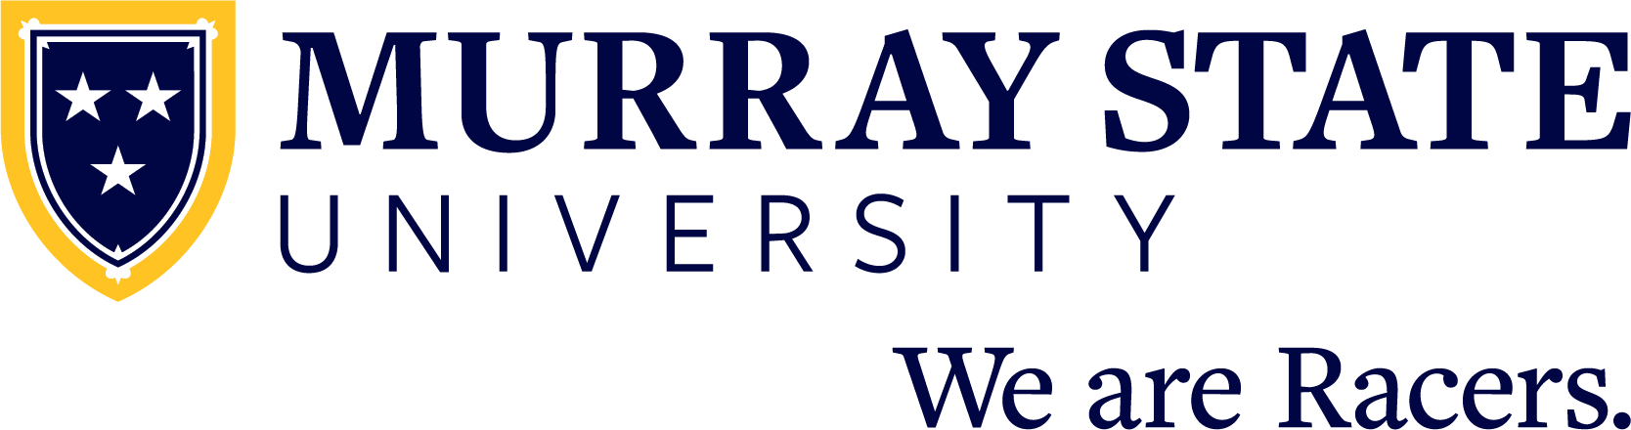

FOR IMMEDIATE RELEASE: Month Day, 20XX

Murray State University announces (student name) as Fall 2021 Dean’s List recipient

MURRAY, Ky. — (Student name) from (city, state and/or country) has been named to the Fall 2021 Dean’s List at Murray State University.

(Student name) is (pursuing a/graduated with) a degree in (academic program).

(INCLUDE ADDITIONAL ACADEMIC HONORS/AWARDS HERE)

A table sortable by city and state, located at murraystate.edu/deanslist, includes the University’s Fall 2021 Dean’s List recipients.
Prospective students who are interested in joining the Racer family for the 2022-23 school year can learn more, schedule an on-campus or virtual visit, and apply for admission at admissions.murraystate.edu.
**
Since 1922, Murray State University has provided a collaborative, opportunity-rich living and learning community that fosters personal growth and professional success through a high-quality college experience. Students receive support from inspiring faculty and staff and will join a distinctive campus community — the Racer Family. With nearly 10,000 students, Murray State prepares the next generation of leaders to join 75,000 successful alumni who make a difference in their community, across the country and around the world. We are Racers. The University’s main campus is located in Murray, Kentucky, and includes five regional campuses in Ft. Campbell, Henderson, Hopkinsville, Madisonville and Paducah.
To learn more about Murray State University, please visit murraystate.edu.

