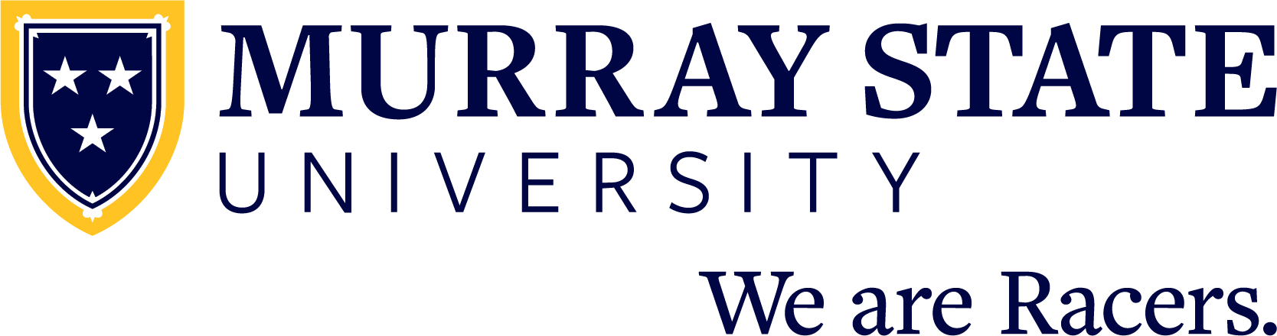

FOR IMMEDIATE RELEASE: Month Day, 20XX

(Student name) graduates from Murray State University

MURRAY, Ky. — (Student name) from (city, state and/or country) has graduated from Murray State University with a (Bachelor/Master/Doctorate/etc) of (Arts/Science/etc) in (major).

(Student name) is the (daughter/son) of (parent’s name or names).

(INCLUDE ACADEMIC HONORS/AWARDS HERE)

A total of 1,464 degree applicants comprise this spring’s graduating class of degree applicants from May and August, including doctoral, specialist, master’s, baccalaureate and associate degrees. A total of 31 states and 22 countries are represented.

There is still time for soon-to-be graduating high school students to apply for admission for the upcoming 2021-22 academic year. Students interested in joining the Racer Family can learn more, schedule a virtual or on-campus visit and apply for admission at admissions.murraystate.edu.

Since 1922, Murray State University has provided a collaborative, opportunity-rich living and learning community that fosters personal growth and professional success through a high-quality college experience. Students receive support from inspiring faculty and staff and will join a distinctive campus community — the Racer Family. With nearly 10,000 students, Murray State prepares the next generation of leaders to join 75,000 successful alumni who make a difference in their community, across the country and around the world. We are Racers. The University’s main campus is located in Murray, Kentucky, and includes five regional campuses in Ft. Campbell, Henderson, Hopkinsville, Madisonville and Paducah.

To learn more about Murray State University, please visit murraystate.edu.

